Data Governance Standards

City of Greensboro Open Data Program

May 2016

DRAFT

Table of Contents

Defining the Vision of the Greensboro’s Open Data Program 3

Program Design and Goals 3

Measuring Success 5

Roles and Responsibilities 6

Leadership Team 7

Data coordinators 8

Current Data Coordinators 9

Identifying and Prioritizing Potential New Datasets 10

Data Inventory 10

Identifying city datasets via the data inventory 10

Identifying shared datasets via the data wish list 11

Review and Gap Analysis 11

Prioritizing Among New Datasets 11

Publishing and Updating Data 13

Configuring Datasets 13

Sensitivity Assessment 14

Publishing Data 15

Quality Assessment 16

Data Updates 16

Purchasing guidelines for city applications and sensors 17

Provision of Data to the Portal 17

Use of Data from the Portal 18

Protected Data 18

Open Data Licensing and Liability Limitations 18

Appendix A: Checklist for Third Party Open Data Providers 19

Dataset Type 19

Geocoding for Tabular Datasets 19

Upload Methodology 19

Protected Data 19

# Defining the Vision of the Greensboro’s Open Data Program

Data created and maintained by the City of Greensboro and the City’s contractors is a public good and, unless considered protected, should be released to and leveraged in service of Greensboro’s residents, businesses, and institutions. Greensboro’s Open Data Program is a set of policies, processes, and technologies for maximizing the value of Greensboro’s data while simultaneously maintaining the highest possible degree of protection for privacy and security.

The open data program increases the value of city data by:

* Releasing data in service of transparency and community engagement, so that residents understand what their city is doing.
* Enabling city staff and the public to use the data in analyses and software applications that help Greensboro deliver services more efficiently.
* Providing businesses and other organizations with relevant data at no cost, so that Greensboro continues to maintain a thriving local economy.
* Removing silos between city departments, thereby fostering data-sharing and enabling efficiency improvements for city service delivery.

The open data program protects privacy and security by:

* Evaluating which datasets should be released to the general public and which datasets should only be released internally to the organization.
* Marshalling technical systems that allow for different tiers of access to the City’s data resources.
* Implementing controls such as anonymization and aggregation to prevent the public release of protected data.
* Soliciting input from city staff and residents about the proper balance of privacy and transparency.

## Program Design and Goals

Greensboro’s Open Data Program is intended to increase community engagement, economic well-being, internal data sharing, data-informed decision-making, and government transparency.[1] These outcomes are the result of efforts by the open data program and its stakeholders to supply city data and market it both internally and externally. Note that these outcomes are also affected by numerous intervening factors such as other city activities, city finances, and the state of the economy. More immediate outcomes of the open data program include an awareness of open data among both city staff and the public, as well as consistent growth of the supply of data. See Figure 1

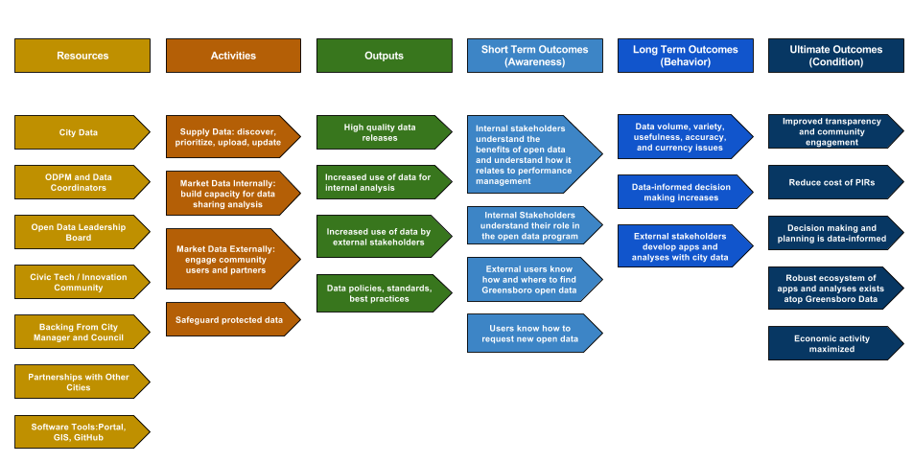

Figure : Logic model illustrating how open data program's resources and activities improve public well-being.

## Measuring Success

Quantitative performance measurement is a nascent but growing part of the open data field. It is important to periodically measure the effectiveness and efficiency of Greensboro’s Open Data Program in order to identify when changes to the program’s operation could be necessary.

At the outset of the Open Data Program, Greensboro will track program measures related to data supply and data use. See Table 1.

Table : Current Performance Measures for Greensboro’s Open Data Program

|  |  |  |  |
| --- | --- | --- | --- |
| **Category** | **Measure** | **Target/Trend** | **Frequency** |
| Data Supply | Number of datasets released | Increase | Quarterly |
| Data Supply | Percent of departments that have completed data inventories | 100% | Annually |
| Data Supply | Percent of departments that have published open data | 100% | Annually |
| Data Supply | Percent of openable datasets published | Increase | Quarterly |
| Data Supply | Percent of datasets with required metadata | 100% | Quarterly |
| Data Supply | Percent of datasets updated on time | 100% | Quarterly |
| Data Supply | Percent of datasets automated | Increase | Annually |
| Data Use | Number of portal views | Increase | Quarterly |
| Data Use | Number of data downloads and API hits | Increase | Quarterly |
| Data Use | Number of city performance indicators associated with open data | Increase | Annually |
| Data Use | Number of data dashboards associated with open data | Increase | Annually |
| Data Use | Number of internal data analytics projects drawing on open data | Increase | Annually |

Within one year of implementation, Greensboro’s Open Data Program will build capacity to use surveys, focus groups, or interviews to measure the program’s long-term performance. These tools will help track progress toward goals related to the program’s various impacts, including economic development, efficient delivery of city services, transparency, and public engagement. See Table 2.

Table : Potential Future Performance Measures for tracking the impact of Greensboro’s Open Data Program

|  |  |  |  |
| --- | --- | --- | --- |
| **Category** | **Measure** | **Trend** | **Measurement Tools** |
| Economic Development | Number of businesses using Greensboro’s open data | Increase | Survey, Interviews, Website Analytics |
| Economic Development | Commercial respondents indicating that open data plays an important role in their businesses | Increase | Survey, Interviews |
| Transparency | Staff hour burden of Public Information Requests | Decrease | Request Tracking System |
| Transparency | Responses indicating satisfaction with transparency of City operations | Increase | Survey |
| Engagement | Number of projects made with open data | Increase | Online project showcase |
| Engagement | Number of Participants at City’s Open Data Events | Increase | Survey |
| City Service Delivery | Internal data sharing through open data portal | Increase | Survey of city staff |
| City Service Delivery | Prevalence of data-driven decision making among city staff | Increase | Survey of city staff |

# Roles and Responsibilities

Greensboro’s data program comprises five groups (see Figure 2):

* **An Open Data Program Manager** who helps to define and execute the vision for the open data program. The program manager sets priorities, outlines policies, and coordinates the open data program’s technical systems and organizational processes.
* **An Open Data Leadership Team** that will assist the program manager with decisions and policies that require specialized knowledge of city operations, legal matters, or technical systems. The leadership team will incorporate public and organizational feedback in discussions concerning the open data policy and specific datasets.
* **Data Coordinators**, distributed among the City’s departments, who will identify potential open datasets, upload datasets to the open data portal, contextualize datasets with descriptive metadata, and periodically update data.
* **City Stats Team**, which makes use of Greensboro’s data to help improve city operations and decision making. This team constitutes the open data program’s main internal customer.
* **The Public**, who will be a major consumer of the City’s open data will communicate and provide feedback to the Leadership Team on the open data program through the Open Data Program Manager.

Note that there is some overlap among these groups. For example, several Data Coordinators and the Open Data Program Manager will sit on the leadership team.

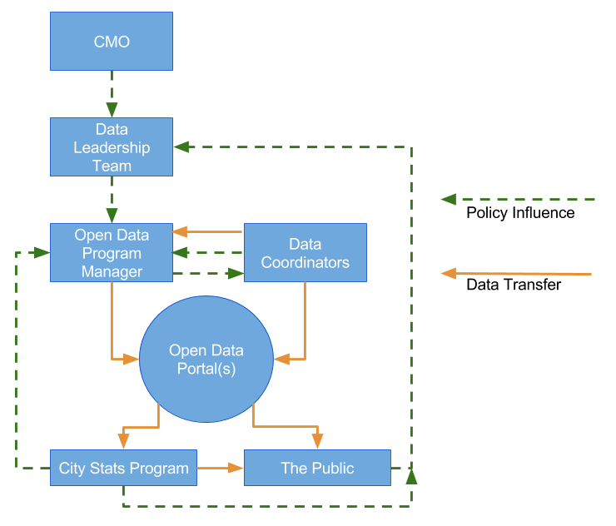  
Figure : Open Data Program Organization. Note that some members may belong to more than one group. The Open Data Program Manager for example also serves on the open data leadership team.

## Leadership Team

The leadership team is an informal group comprising staff who make high level decisions about data creation, curation, and consumption in the City. Table 3 identifies members of the leadership team based on the function they might serve. Note that some individuals might serve more than one function.

Table : Open Data Leadership Team ***** **Update with Greensboro Staff \*\*\*\*\***

| Role | Description | Greensboro Staff |
| --- | --- | --- |
| Executive Support | Executive level support and encouragement of the open data process is critical to gaining buy in citywide. The City Manager or Assistant City Manager(s) need not be engaged all the time, however, it is extremely valuable for he or she to publicly announce a new open data program or policy, as well as provide encouragement and support to the City’s open data leadership team. | Mayor  City Manager  Assistant City Manager(s)  CIO  Deputy CIO |
| Strategic Alignment | Responsible for overall program leadership; ensures alignment with overall city and administration goals; creates accountability for department heads and delegated departmental staff; helps set and approve priorities for data releases; reports to the City Manager or Assistant City Manager(s) on program activities. | Open Data Program Manager  Communications Director  IT Project Manager |
| Legal Strategy | Assists in developing policy and guidance materials for releasing datasets; develops terms of service and licensing for data access and usage; helps resolve legal considerations for complex datasets; connects dataset publishing to freedom of information requests. | City Legal Team |
| Communications Strategy | Ensures public datasets have messaging consistent with other city goals and programs; assists other senior executives with potential responses to public input on published datasets; oversees public engagement activities and events. | Communications Director  Open Data Program Manager |
| Technical Operations | Oversees the technical aspects of open data, such as maintaining the public data catalog, extracting data from internal IT systems, and ensuring public data is kept up to date. | Open Data Program Manager  Database Administrator |
| Data Coordinators | The person or team in a department who uses the data to carry out their daily business, Data Coordinators work with the program manager, data analysts (see below,) and others to ensure the publicly released data is accurate, well documented, and up to date. | Existing Data Coordinators in each department |
| Data Analysis | Reviews source data systems; recommends specific data elements for release approval; helps develop public documentation; handles manual data publishing if needed. | Existing Data Coordinators  City analysts  Open Data Program Manager |
| Database Engineering | Build and configure the tools needed to routinely copy data from city technology systems to the open data website. | Open Data Program Manager  Database Administrator |
| Internal Users | Departmental staff who are important consumers of open data and use data to make decisions, streamline processes, and improve operations; offer perspectives on using data for cross-departmental and cross-organizational collaboration. | City analysts |

## Data coordinators

Data Coordinators are city staff who have unique expertise or knowledge about data specific to a particular department or city function. They help identify, characterize, and prioritize new open data releases. Data Coordinators are the main drivers of the City’s annual data inventory and the main suppliers of data to Greensboro’s open data portal. Figure 3 illustrates the attributes of a Greensboro Data Coordinator.

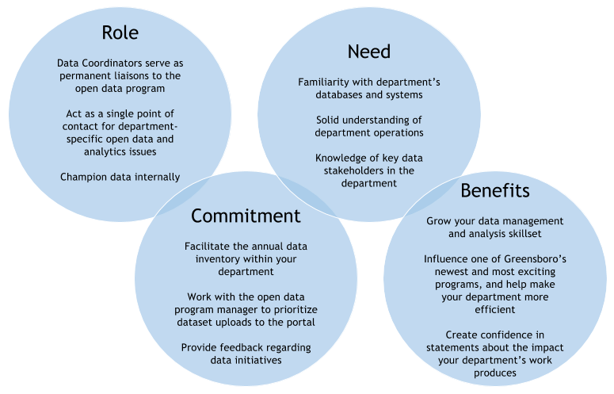

Figure : Role, need, commitment, and benefits of Data Coordinators

### Current Data Coordinators

Table 4 identifies Data Coordinators (by department and title) with current permissions to upload data to the City’s open data portal. This table will be updated annually.

Table : City of Greensboro Departmental Data Coordinators **** Most Data Coordinators will be identified after the Open Data Stakeholders are convened to garner buy-in for the program. ****

| Dept. | Position | | Portal Role |
| --- | --- | --- | --- |
| Budget | Budget Database Specialist |  | |
| Finance | Principal Analyst |  | |
| Communications | ? |  | |
| Human Resources | ? |  | |
| Legal | ? |  | |
| Economic Development | ? |  | |
| CMO/Legislative | ? |  | |
| Human Relations | ? |  | |
| Libraries & Museums | ? |  | |
| Neighborhood Development | ? |  | |
| Parks and Recreation | ? |  | |
| Coliseum | Coliseum Business Office Manager |  | |
| Field Operations | ? |  | |
| Engineering and Inspections | Business and Technology Manager | Editor | |
| Transportation | ? |  | |
| Water Resources | ? | Editor | |
| Planning | Community Planning Manager |  | |
| Information Technology | Open Data Program Manager | Administrator | |
| Information Technology | CIO | Viewer | |
| Information Technology | Deputy CIO | Viewer | |
| Information Technology | IT Project Manager | Editor | |
| Information Technology | Database Administrator | Administrator | |
| Information Technology | ERP Analyst | Editor | |
| Information Technology | GIS Manager | Editor | |
| Information Technology | GIS Analyst | Editor | |
| Information Technology | GIS Database Administrator |  | |
| Police | Crime Analysis Supervisor? | Editor | |
| Fire | Battalion Chief | Editor | |
| GM911 | ? |  | |

# Identifying and Prioritizing Potential New Datasets

Underlying Greensboro’s Open Data Program is a concerted effort across all Greensboro departments to identify and provide datasets for the public. The main role of Data Coordinators is the identification, prioritization, and characterization of datasets for upload to the portal. Under the Open Data Program Manager’s direction and guidance, the dataset inventory will occur annually as well as on an ad hoc basis throughout the year as new datasets arise. The dataset inventory will be in part a learning process. As a result, changes to this guidance will be made by the Program Manager as needed based on feedback from Data Coordinators and others involved in the inventory process. For the purposes of this inventory, a dataset is defined as the contents of a single database table, a defined view, or a spreadsheet. The dataset is provided as a single combination of unique rows and corresponding columns describing each row.

## Data Inventory

The annual data inventory process will include the following steps:

1. Identification of city datasets and completion of the data inventory worksheet.
   1. Identify departmental data sources (e.g., databases, spreadsheets, shared drives, etc.).
   2. Identify all single datasets that can be pulled from each of the data sources.
   3. Identify and coordinate with departmental data owners that can help complete the inventory for each data source.
2. Identification of data shared among departments and completion of the data “wish list.”
3. Review and Gap Analysis.
4. Prioritization and upload.

### Identifying city datasets via the data inventory

Each summer, data coordinators around the City will use an inventory template to list all datasets created or managed by their department. Note that all data will be inventoried including datasets that may contain sensitive or restricted data, or datasets that are not considered ‘valuable’ to the open data program. Each dataset will include the following information:

* Department (e.g., Engineering and Inspections, Police)
* Division (e.g., Building Inspections, Crime Analysis)
* Category (e.g., Permit, Public Safety)
* Dataset (e.g., Building Permits, Violent Crimes)
* Format (e.g., CSV, ArcGIS Feature Class)
* Source (e.g., SQL DB, Access DB, SDE GeoDatabase)
* Update Frequency (e.g., daily, weekly, annually)
* Data Coordinator (e.g., John Smith-IT)
* Sensitive data (yes/no; description)
* Description and other notes

### Identifying shared datasets via the data wish list

While filling out the inventory, Data Coordinators will also fill out a data “wish list,” specifying datasets their department procures or wishes to procure from other departments in the City. Departments around the City frequently share data with one another, and any current interdepartmental data exchanges should be included in this list to identify opportunities to create efficiencies in existing data sharing processes. One of the main advantages of the open data program is that it facilitates efficient inter-departmental data sharing by housing city data openly on a centralized internet portal. Assuming that datasets are kept up-to-date, the portal enables analytics, dashboards, and other decision support tools. The data wish list will include these fields:

* Dataset (e.g., Building Inspections)
* Requesting Department (e.g., Fire Department)
* Owner Department (e.g., Engineering and Inspections Department)
* Description of Use (e.g., Used to predict fire risks and vulnerabilities)
* Requested Update Frequency (e.g., weekly)
* Current Contact (e.g., Bill Jones)
* Notes (we currently email Bill once a quarter for this information)

### Review and Gap Analysis

The inventory review is intended to identify any datasets missed by Data Coordinators. Greensboro employs a series of relational databases to house complex datasets, and data within these important databases could be missed by some coordinators. The Open Data Program Manager will work with database owners to conduct a gap analysis between the results of the data inventory and the contents of the City’s various relational databases.

## Prioritizing Among New Datasets

Following the inventory process, the departmental Data Coordinators in consultation with the Open Data Program Manager will propose draft prioritizations for datasets in their respective inventories. The Open Data Program Manager will coordinate with the open data leadership team to then consolidate the departmental inventories into a master dataset prioritization inventory. The dataset prioritizations will be based on two dimensions, the demand/value of the dataset, and the ease of publication. Figure 4 illustrates how datasets will be compared across these two dimensions. After each annual data inventory, the open data team will rate each dataset as high, medium, or low in each area as defined below. Departments will review the draft ratings and have an opportunity to submit corrections. Datasets that are highest in terms of value and ease of publication will be prioritized for upload to the open data portal.

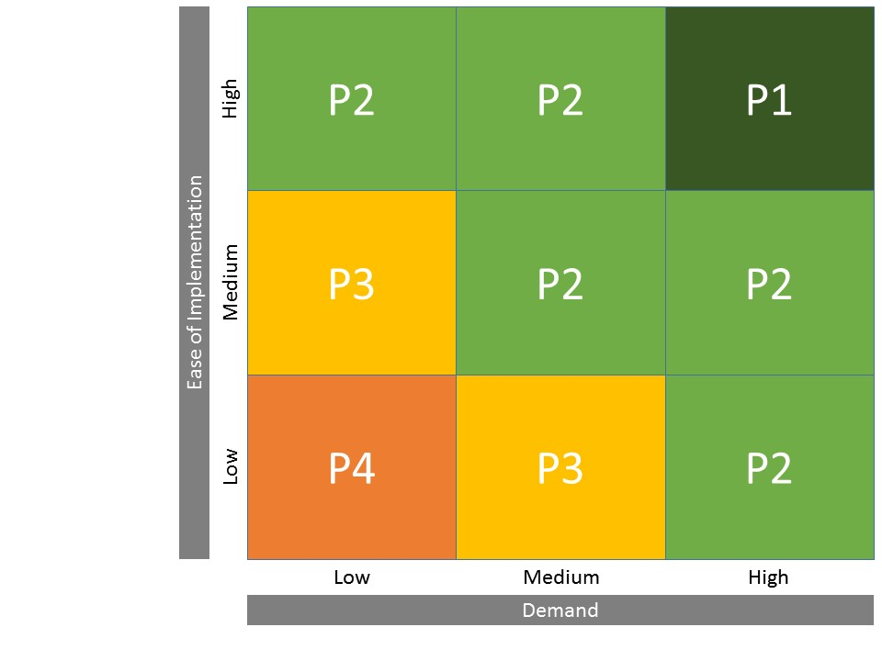

Figure : Dataset Prioritization Matrix. Data highest in demand and ease of implementation will be considered first priority. (Source: San Francisco Open Data Program, available online at datasf.org)

* **Demand/Value**:
  1. **Low** – The dataset historically has had little or no public demand. Little organizational, departmental, business, or public benefit has currently been identified.
  2. **Medium** – At least one of the following is true concerning the dataset. The dataset has been previously requested, or has the potential to be requested by the public or business community. The dataset has been included on a department data wish list as defined in the previous section.
  3. **High** – The dataset is tied to a performance management goal, a city council or city manager’s office initiative, or would provide immediate benefit to multiple departments, the organization, or the community for making data informed decisions, or other purpose.
* **Ease of Publication**:
  1. **Low** – One or more of the following is true concerning the dataset. The dataset contains significant sensitivity concerns that will require an extended sensitivity review process, a legal department review, or a significant revision of the dataset to resolve. The dataset requires significant configuration to generate the file in a format the portal accepts. Setting up the automation process will require a change in business process and will require significant effort.
  2. **Medium** – The dataset configuration will require a concerted effort, but can be generated in a format that the portal accepts without deviating from the established business process. Sensitivity concerns are minor and successfully addressed by the Data Coordinator, and the Open Data Program Manager. Metadata is able to be generated for the dataset within the current business process for creating open datasets.
  3. **High** – Effort to channel the dataset through the open data process is low; most of the following are true concerning the dataset. Very minor (if any) sensitivity concerns are found in the dataset, and are quickly and easily mitigated by the Data Coordinator and Program Manager. Metadata is already accessible, or easy to produce. The data is already in a format that can be uploaded to the portal, or is easily configured and converted. An existing automation process used to maintain data on the portal can be implemented for the dataset.

# Publishing and Updating Data

Following data prioritization, ongoing efforts will be made to upload data to the city’s open data portal. Data publication entails six steps: configure the dataset, sensitivity review, risk mitigation, initial upload, QA review, and publication. See Figure 5 for an illustration of this workflow.

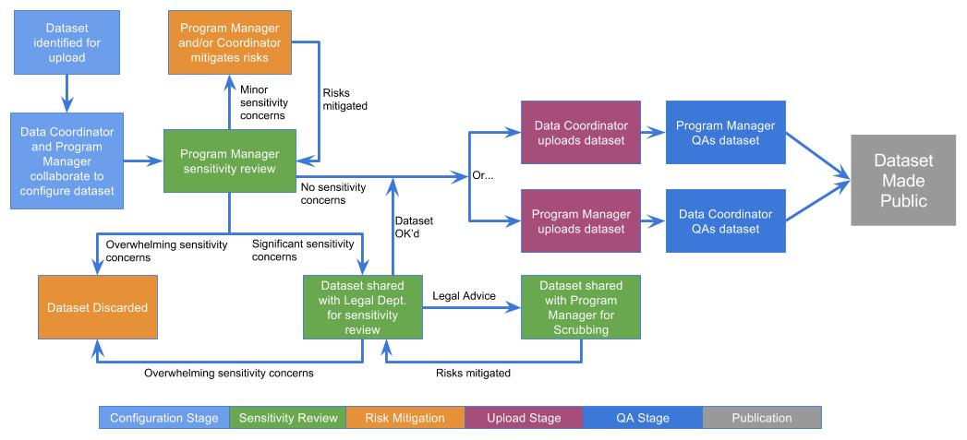

Figure 5: Open Data Workflow

## Configuring Datasets

Once a dataset is identified as a candidate for releasing as open data on the portal, the Data Coordinator and Open Data Program Manager will collaborate on the best way to configure and structure the dataset for publishing to the portal, as well as the maintenance schedule for the dataset.

## Sensitivity Assessment

At the core of Greensboro’s Open Data Program is a tension between striving for transparency while simultaneously ensuring the security of protected information. As indicated by Figure 5, multiple parties have the opportunity to review a dataset for sensitivities related to privacy and security— Data Coordinators, and the Open Data Program Manager will assess every new dataset, and the legal department will have the opportunity to review particularly contentious datasets. These redundant checks for protected data exist because every dataset is unique and many sensitivities can be quite nuanced, demanding a careful weighing of risks and benefits. Greensboro’s open data policy defines protected data as follows:

* Trade secrets (Which may include vendor software, technical specifications or other intellectual property);
* Proprietary information such as license agreements or fees, copyrights, patents, etc.
* Personal identifying information as defined by NCGS 132-1.10;
* Information contained in the City’s personnel files as provided by NCGS 160A-168, except for certain categories that must be disclosed;
* Information related to criminal investigations conducted by the City and records of criminal intelligence information compiled by the City;
* Billing information of customers compiled and maintained in connection with the City providing utility services;
* Sensitive security information as defined for Protection of Sensitive Security Information in title 49 Code of Federal Regulations (CFR) Part 1520 regarding Homeland Security;
* Building plans of City-owned buildings or infrastructure;
* Local tax records of the City that contain information about a taxpayer’s income or receipts;
* The security features of the City’s electronic data processing systems, information technology systems, telecommunications networks, or electronic security systems as provided by NCGS 132-6.1 and-
* Any data collected from a person applying for financial or other types of assistance including, but not limited to, their income and bank accounts, etc.

Though the Open Data Program Manager identifies sensitivity issues during the data prioritization phase and before upload, a thorough review of all privacy and security concerns is necessary. The Open Data Program Manager conducts the first stage of the sensitivity review, identifying potential concerns as either minor, significant, or overwhelming.

* + *Minor concerns*: such as a column that can be easily removed, are communicated to the program manager or Data Coordinator for mitigation. The dataset is then re-reviewed by the program manager.
  + *Significant concerns*: represent issues that are not easily resolved but do not immediately disqualify the dataset, such as the possibility that anonymized individuals in a dataset could be easily re-identified when the dataset is combined with another dataset on the portal. Once the Open Data Program Manager identifies such concerns, the dataset is forwarded to the Legal Department for review.
  + *Overwhelming concerns*: immediately disqualify a dataset from being posted to open data. Examples include datasets that are protected by law or that would pose a security risk. A discerning eye should be used to determine if any portion of the dataset that does not violate the open data policy could be released on the portal. Datasets identified as overwhelmingly concerning are not uploaded to the portal.

For datasets that show evidence of one or more of these classes of sensitive data, a second stage of sensitivity review will identify the proper risk mitigation technique, including but not limited to:

* Redaction (e.g., deleting a column of names).
* Anonymization (e.g., reducing the precision of addresses).
* Aggregation (e.g., averaging a dataset by age group).
* Constraining access (e.g., limiting access to city staff).
* Forgoing publication and discarding the dataset.

## Publishing Data

Datasets are uploaded to Greensboro’s open data portal in two different ways:

* **Data Coordinators upload data directly to the portal.** This method is ideal for large departments that have many datasets to contribute to Greensboro’s open data portal. The Open Data Program Manager is responsible for training these Data Coordinators on using the City’s open data portal. Data Coordinators will coordinate the dataset upload with the Open Data Program Manager. In addition to uploading datasets, owners will input metadata (e.g., readme text, column descriptions) to contextualize datasets and dataset attributes.After an owner has uploaded a new dataset and entered metadata, he or she will share the private dataset with the Open Data Program Manager for review.
* **Data Coordinators send data to the Open Data Program Manager for upload to the portal.** This method is intended for smaller departments and groups that may have only a small number of datasets to contribute to Greensboro’s open data portal. Along with new datasets, owners will send the Open Data Program Manager metadata (e.g., a readme text file, column descriptions) to contextualize datasets and dataset attributes. The program manager will upload new datasets, input metadata, and then share the private dataset with Data Coordinators for review.

## Quality Assessment

After a dataset and associated metadata have been uploaded to the portal, but before it is released publicly,[2] a final quality assessment (QA) review takes place to find and correct any errors in the data itself or in the metadata. The QA is conducted by either the program manager or the Data Coordinator (whoever *did not* upload the data, as the intent is to subject the dataset to a fresh set of eyes).

Datasets that pass both the sensitivity review and QA are made public on the portal.

Each dataset is unique and requires a different process to review and assess quality (QA). However, certain commonalities apply across all datasets. Greensboro’s Open Data Program employs the following quality standards during the dataset QA process:

* The dataset is the most complete, accurate, and current version appropriate for public release.
* The data have been spot checked for common errors such as missing and misplaced values.
* Any missing data points are left as null, but the meaning of null is defined in the dataset’s metadata.
* Columns are formatted appropriately.
* Metadata is complete, concise, and free of jargon.
* Metadata explain the process used to create the data and summarize any changes.
* Metadata clearly explain any limitations or omissions for each dataset.
* Metadata clearly identify an update frequency and plan.

The Greensboro Open Data Program is not, however, a data editing program. No dataset is perfect. Data Coordinators will not be asked to substantially change or improve datasets pulled from city systems before uploading them to the portal. Data Coordinators are not asked to impute missing values, though they may do so if they wish. The primary goal of the Open Data Program is not to improve city data, but rather to share our existing data with the public and among city staff. With this in mind, the program also provides an opportunity, to gain feedback about the quality of our data from other departments and the public. Any improvement to internal processes for data creation and curation that results from the Open Data Program or associated feedback will be considered welcome but auxiliary.

## Data Updates

A successful open data program requires up-to-date data. When submitting a dataset to be published to the portal, Data Coordinators must also submit an update plan specifying how often the dataset will be refreshed. Coordinators are responsible (with ‘as needed’ assistance from the Open Data Program Manager) for all manual updates to datasets. Whenever possible, coordinators will update an existing dataset instead of creating a new dataset.[3]

Nevertheless, Data Coordinators may have limited time to monitor the freshness of datasets posted on the portal. The Open Data Program Manager will employ two tactics to help ensure that the Greensboro data portal remains up to date:

* **Active monitoring of dataset freshness.** The Open Data Program Manager will track each dataset on the portal. The Open Data Program Manager will alert Data Coordinators when a dataset is identified as out of date and needs to be refreshed.
* **Automation.** For datasets that need to be updated at least once per month or more, the Open Data Program Manager will work with Data Coordinators and the IT database administrator to implement automatic updates, where appropriate. The Data Coordinator will need to provide the Open Data Program Manager with read access for the relevant files and databases.

# Purchasing guidelines for city applications and sensors

In order to ensure a robust supply of open data, Greensboro must strive to ensure that its many different sensors and software applications are capable of exporting data in a format that is compatible with our open data portal software. Both the purchasing department and individual city departments initiating purchases that will result in the collection of data should consider open data as a factor when finalizing purchases. This section is intended to facilitate that review.

Today, Greensboro maintains a Socrata open data portal. However, the purchasing guidelines in this section are intended to be broad enough to apply to a diverse array of open data portal platforms. (e.g., ArcGIS Open Data Portal).

Appendix A: Checklist for Third Party Open Data Providers includes a checklist for vendors to use when reviewing these guidelines.

## Provision of Data to the Portal

All applications and analyses employed by Greensboro, whether constructed in-house or procured from third-party vendors, should produce data capable of being published to the Greensboro Open Data Portal. With the exception of protected data, including confidential business information, data provided to Greensboro will be supplied without IP restrictions on use.

Data can be published to the Portal through Socrata’s RESTful “Publisher” API or uploaded as discrete files through the Portal’s upload wizard.

For tabular datasets, the Portal supports the following file types:

* CSV
* TSV
* XLS
* XLSX

Tabular datasets may include text, numbers (including money and percentages), booleans, URLs and email addresses, locations, and dates/times. Upon upload, the Portal can automatically geocode tabular datasets that include geospatial data such as addresses. Any application that geocodes data before upload must specify geocoding methodology. For geospatial data, the Portal supports KML, KMZ, and ESRI Shapefiles. Additionally, the Portal accepts non-data file types such as PDF. However, preference is given to applications and analyses that produce machine readable files. If a Data Coordinator identifies a potential dataset that does not conform to compatible file format that the current portal(s) accept(s), the Data Coordinator will coordinate with the Open Data Program Manager to determine the best solution to incorporate the dataset in question to the appropriate portal.

## Use of Data from the Portal

Open data hosted on the Portal is available for use by Greensboro staff, vendors, contractors, the public, and applications. Data may be procured from the Portal via RESTful API or manual download. Preference will be given to applications and analyses that consume Greensboro data via the Portal rather than via FTP, or emailed files.

## Protected Data

The City of Greensboro’s Open Data Policy defines protected data (see Sensitivity Assessment section). Datasets meeting some or all of these criteria are exempt from Greensboro’s open data requirements at the discretion of the Open Data Program Manager. Applications and sensors dealing primarily with protected data are exempt from these purchasing guidelines.

# Open Data Licensing and Liability Limitations

TBD

(Creative Commons / Public Domain)

# Appendix A: Checklist for Third Party Open Data Providers

## Dataset Type

* Tabular
* CSV
* TSV
* XLS or XLSX
* Other: _____________
* Geospatial
  + KML
  + KMS
  + ESRI Shapefiles
  + Other:_____________
* Other
  + Specify: ___________

## Geocoding for Tabular Datasets

* This tabular dataset does not contain geospatial information
* Geocoding will be completed using the Portal’s after-upload geocoder
* Geocoding will be completed before upload
* Specify methodology: _____________________________________

## Upload Methodology

This dataset will be uploaded to the Portal:

* Manually, via the Portal’s upload wizard
* Through the Socrata Publisher API
* Via the Safe Software FME
* Specify FME reader: _______________________________________

## Protected Data

* This dataset does not qualify as protect data
* This dataset qualifies as protected data, because it:
* Is exempt from disclosure pursuant to North Carolina Laws, including but not limited to the North Carolina Public Records Law
* Contains a significant amount of Data and where the disclosure of such Data would impose an undue financial or administrative burden on the City
* Reflects the internal deliberative or administrative process(es) of the City, including, but not limited to, Data and Data Sets relating to negotiating positions, future procurements or pending or reasonably anticipated legal or administrative proceedings
* Is subject to privacy laws, student records laws or subject to copyright, patent, trademark or trade secret protection, or to a confidentiality agreement, attorney/client privilege or that are otherwise protected by law or contract
* Includes or constitutes proprietary applications, computer code, software, operating systems or similar materials
* Includes or constitutes employment records, internal employee-related directories or lists, facilities data, information technology, or internal service-desk data of the City
* Could privacy, confidentiality or security concerns or jeopardize or have the potential to jeopardize public health, safety or welfare.
* Other:___________________________________________________________

EXPLANATION:

1. In addition to being an important democratic principle, transparency has the additional benefit of reducing the cost of public information requests.
2. Datasets not made “public” on the Socrata portal are not widely viewable within the organization, either. Private datasets can only be viewed by those the dataset has been “shared with” by the coordinator or a portal administrator.
3. For example, if a dataset called *Flying Car Data 2005-2014* already exists, then the flying car Data Coordinator should strive to update it with 2015 data instead of creating a standalone 2015 dataset.